**SMART FACIAL ATTENDANCE SYSTEM**

**A PROJECT SYNOPSIS**

***Submitted by***

**Gaurav Kuamr Verma - 2004920100021**

**ADITYA PANDEY - 2004921530001**

**PRATYUSH HARSH - 2004920100035**

**Raj Aryan - 2004920100038**

***Under the Guidance***

***Of***

**Rohit Negi**

***in partial fulfillment for the award of the degree***

***of***

**Bachelor Of Technology**

**In**

**Computer Science Engineering , 4th YEAR & 7th SEMSESTER**



**KCC Institute of Technology & Management**

Affiliated by A.P.J. Abdul Kalam Technical University (AKTU)

Knowledge Park, Greater Noida, U.P

**December & 2023**

**SMART FACIAL ATTENDANCE SYSTEM**

**AIM & OBJECTIVE**

***AIM :***

Develop a Facial Attendance System that utilizes advanced facial recognition technology to automate and optimize the attendance tracking process for enhanced accuracy and efficiency.

***OBJECTIVE :***

**1. Specific :**

- Develop a facial recognition algorithm capable of accurately identifying individuals in diverse environmental conditions.

**2. Measurable :**

- Achieve a recognition accuracy of at least 98% for registered individuals across various lighting and facial orientation scenarios.

**3. Achievable:**

- Design and implement a scalable system capable of managing a large database of users while ensuring real-time performance.

**4. Relevant:**

- Ensure compliance with privacy laws and ethical guidelines by implementing stringent data protection measures and obtaining user consent for data usage.

**5. Time-bound:**

- Complete the prototype development and initial testing phase within a timeline of six months.

These SMART objectives provide a clear direction for the project, outlining specific, measurable, achievable, relevant, and time-bound targets to guide the development of the Facial Attendance System.

**Brief literature review :**

A smart facial attendance system is an innovative application of facial recognition technology in the domain of attendance management. This technology has gained prominence due to its ability to offer a more efficient and secure alternative to traditional attendance tracking methods. Here's a brief literature review on smart facial attendance systems:

**Facial Recognition Technology:**

Facial recognition technology has witnessed significant advancements, enabling accurate and rapid identification of individuals based on their facial features.

Researchers have focused on improving the accuracy and reliability of facial recognition algorithms, addressing challenges such as variations in lighting conditions, pose, and facial expressions.

**Attendance Management Systems:**

Traditional attendance systems, relying on manual methods like paper registers or card swiping, are prone to errors and can be time-consuming.

Smart facial attendance systems offer a seamless and contactless solution, reducing the likelihood of errors and saving time for both administrators and attendees.

**Security and Privacy Concerns:**

Studies have explored the security and privacy implications of facial recognition technology in attendance systems.

Privacy concerns related to the collection and storage of facial biometric data have been discussed, emphasizing the importance of robust data protection measures.

**Integration with Cloud Computing:**

Some literature emphasizes the integration of smart facial attendance systems with cloud computing for enhanced scalability and accessibility.

Cloud-based solutions allow real-time data synchronization and remote monitoring, making it convenient for administrators to manage attendance records.

**User Acceptance and Usability:**

Research has examined the acceptance of smart facial attendance systems among users, including both administrators and employees/students.

Usability studies focus on user experience, exploring factors such as system reliability, ease of use, and user satisfaction.

**Implementation in Educational and Corporate Settings:**

Studies have investigated the implementation of facial attendance systems educational institutions and corporate settings.

Findings highlight the potential benefits, including improved efficiency, reduced administrative workload, and enhanced security.

**Ethical Considerations:**

Literature also delves into the ethical considerations associated with the deployment of facial recognition technology in attendance systems.

Discussions encompass issues like consent, transparency, and the potential for bias in recognition algorithms.

**Future Directions and Challenges:**

Scholars have identified areas for future research and development, such as improving the robustness of facial recognition algorithms, addressing ethical concerns, and exploring novel applications beyond attendance tracking

**METHADOLOGY /EXPERIMENTAL DESIGN :**

**1. Objective Definition:**

Clearly define the objectives of the experiment, such as assessing the accuracy of the facial recognition system, evaluating its usability, and identifying potential challenges.

**2. Selection of Participants:**

Identify and recruit participants representative of the system's intended user population (e.g., employees, students).

Ensure a diverse participant group considering factors like age, gender, and ethnic background to assess system performance across different demographics.

**3. Ethical Considerations:**

Obtain informed consent from participants, explaining the purpose of the experiment, the data collected, and how it will be used.

Address privacy concerns and assure participants of data protection measures.

**4. Experimental Environment:**

Set up the experimental environment to mimic real-world conditions where the smart facial attendance system will be deployed.

Consider variations in lighting, different camera angles, and potential distractions.

**5. Baseline Assessment:**

Before implementing the facial attendance system, collect baseline data using traditional attendance methods (e.g., manual attendance, ID card swiping).

This serves as a point of comparison for the smart facial attendance system.

**6. System Implementation:**

Deploy the smart facial attendance system according to the designed methodology.

Ensure that the system is properly calibrated and configured to capture facial features accurately.

**7. Data Collection:**

Capture attendance data using the smart facial attendance system for a specified period.

Record any issues, such as false positives, false negatives, and instances of system errors.

**8. User Feedback and Satisfaction:**

Gather feedback from participants regarding their experience with the smart facial attendance system.

Use surveys, interviews, or usability tests to assess user satisfaction and identify potential areas for improvement.

**9. Accuracy Assessment:**

Compare the attendance data collected by the smart facial system with the baseline data to assess accuracy.

Calculate metrics such as precision, recall, and F1 score to quantify the system's performance.

**10. Error Analysis:**

Conduct a detailed analysis of errors, including the reasons for false positives and false negatives.

Identify patterns in misidentification and assess the impact on overall system reliability.

**11. Usability Testing:**

Evaluate the usability of the system by assessing the ease of use, user interface design, and overall user experience.

Identify any usability issues that may impact the system's adoption.

**12. Security and Privacy Assessment:**

Evaluate the security measures in place to protect facial biometric data.

Assess the system's compliance with privacy regulations and its ability to prevent unauthorized access.

**13. Statistical Analysis:**

Perform statistical analyses to validate the significance of any differences between the smart facial attendance system and the baseline methods.

Consider using appropriate statistical tests based on the nature of the data (e.g., t-tests, chi-square tests).

**14. Documentation:**

Document all aspects of the experiment, including participant demographics, system settings, and results.

Maintain a record of any issues encountered and steps taken to address them.

**15. Results Presentation:**

Summarize the findings in a clear and concise manner.

Present results in the form of tables, charts, and graphs to facilitate easy interpretation.

**16. Conclusion and Recommendations:**

Conclude the experiment by summarizing key findings.

Provide recommendations for improvements or further research based on the observed results.

**EXPECTED OUTPUT :**

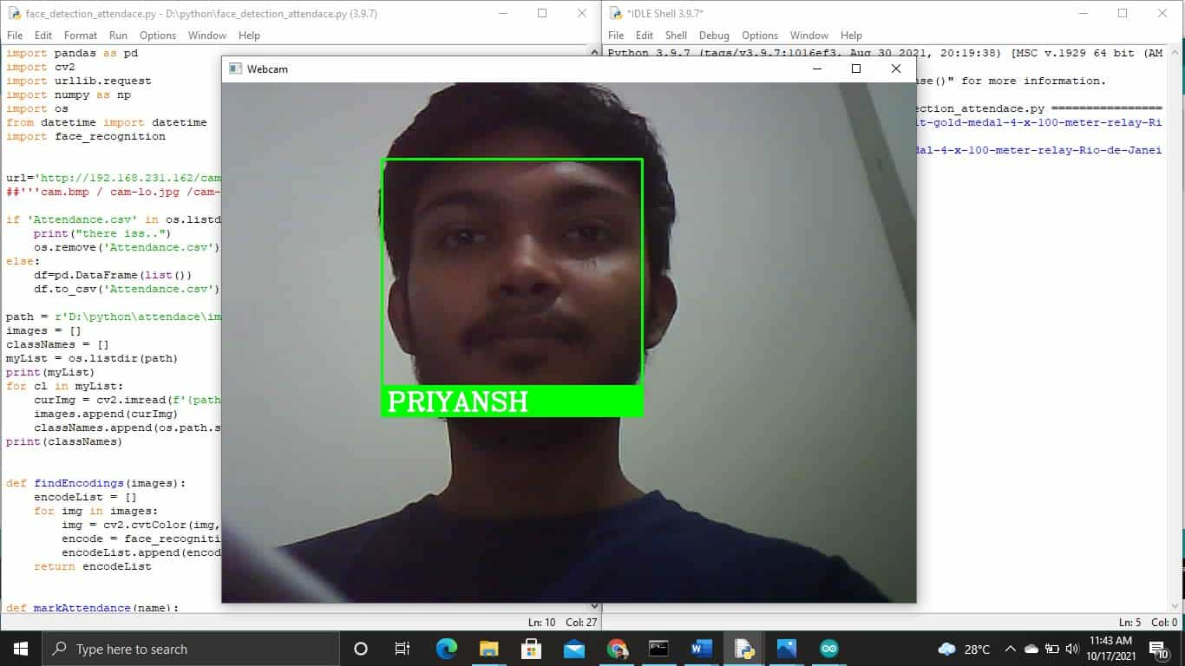**Fig. 1 – Capturing And Analyzing Students Face For Attendance**

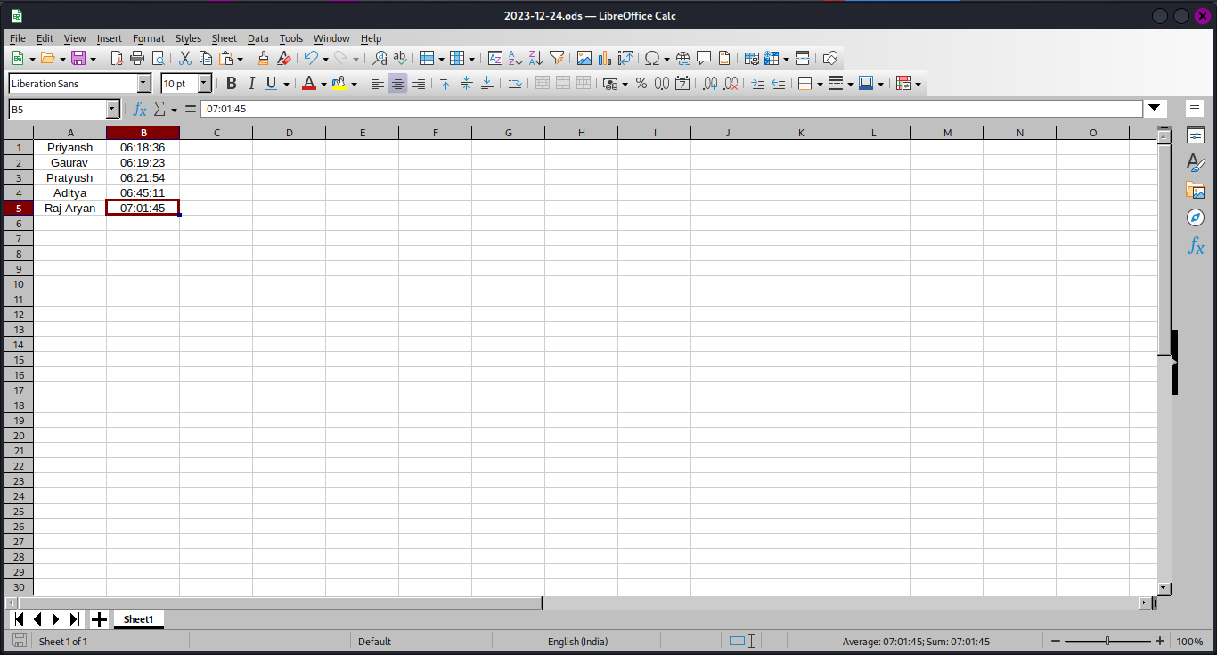**Fig. 2 – Taking The Record of Students Attendance With Time And Date**